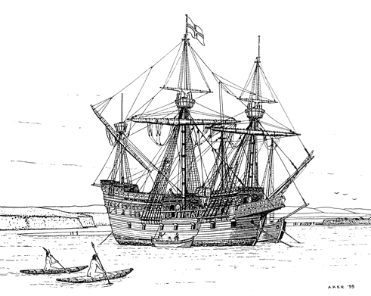
Drake Navigators Guild
Francis Drake
At Drakes Bay
1579
Advanced information
for the National Historic Landmark Dedication
of October 22, 2016

September 18, 2016

Contents
Summary 3
Drake before the Circumnavigation 4
Drake Timeline 5
Overview of the Voyage 6
Voyage Timeline 8
The Golden Hind 9
The Crew 10
Drake at Drakes Bay 11
Visiting the Landing Site 12
Existing Monuments 14
At the landing site: 14
At the Lifesaving Station: 15
At Drake’s Beach 15
What is a National Historic Landmark? 16
The NHL Process 17
What is the District? 18
Sebastian Rodrigues Cermeño’s Visit 18
The Coast Miwok 19
How Did the Work on the NHL Get Done? 19
The Plaque Ceremony 19
The Drake Navigators Guild 19
Establishing the Location 20
Resources 21
The October 22, 2016, Events 24
Technical Notes 25
Contact 25

Summary
Francis Drake’s landing at Drake’s Cove at Drakes Bay in Marin County, California in 1579 and his five-week stay established several important firsts:
- First English claim on what would become the United States of America (before east coast claims such as Roanoke in 1585, Jamestown in 1607 and Plymouth in 1620).
- First European interactions with the Coast Miwok people. These were friendly exchanges among cultures which had little understanding of each other.
- The first service of the Church of England and the use of the Book of Common Prayer in what would become the United States. These traditions are continued by the Anglican Church in America.
- The first transfer of European cultural goods, including Chinese porcelains, to the Coast Miwok people.
- First use of the term “Nova Albion” (New England) for the USA. This refers to the white cliffs at Drakes Bay.
Drake’s overall voyage achieved several important milestones:
- First successful circumnavigation of the Earth by a commander. (Magellan died before getting home).
- First English entry into the Pacific Ocean via the Straits of Magellan.
- Beginning of the shift of sea power from Spain toward England.
- Longest continuous sailing to date (9,600 miles).
- 47 to 1 payout to investors.
The overall Drake circumnavigation story is that of the most daring, successful sailing voyage in history.
Combined with the Sebastian Rodriguez Cermeño visit 16 years later, these sixteenth Century contacts form the earliest meetings among English, Native American, Spanish, Mexican, Filipino and Chinese people.

Drake before the Circumnavigation
Francis Drake’s name instantly evokes romantic images of a fabled Elizabethan world peopled by a virgin queen, gallant noblemen, and swashbuckling corsairs. Those images were based on the solid reality of Drake’s adventurous life and times. As Sir Francis Drake, his name resounds through the centuries as Elizabethan England’s greatest sea warrior.
Francis Drake rose from the poverty and obscurity of childhood in an old hulk, and apprenticeship in a small trading ship at age twelve, through crewman’s experiences in the trading fleets of his cousin John Hawkins in voyages to Africa and the Spanish New World which tested the limits of Spanish tolerance of foreign merchants. Drake’s defining moment came in 1568, near the end of a successful slaving and trading voyage, when Hawkins’s seven ships were forced into the Mexican port of San Juan de Ulua by storm damage. The Englishmen were purchasing supplies and repairing their ships when the annual Spanish trading fleet, bearing the new Viceroy of Mexico, Don Martín Enriquez, arrived and entered the harbor under mutual guarantees of peaceful intercourse. Two days later, the Spaniards attacked the Englishmen, hammering them with cannon and sending waves of infantrymen to storm the ships’ sides. Only two English ships escaped: Queen Elizabeth’s ship Minion with Hawkins in command, and the tiny Judith under Captain Francis Drake. More than two hundred Englishmen were killed or left to the ministrations of Don Martín and the Spanish Inquisition.
Queen Elizabeth could authorize retribution for this perfidy. Under the well-established law of reprisal, Hawkins could obtain a license to attack Spanish ships to recoup his losses. But John Hawkins was too well known and too useful to Elizabeth for her to openly send him to the Azores, the West Indies, or the Spanish Main. The struggle between Protestant England and Catholic Spain over trade, closed seas, European alliances, and religion was not yet an open war. The unknown Francis Drake, however, could be let loose to pursue his personal war with Viceroy Don Martín Enriquez and King Philip II of Spain. Quixotic? Certainly -- at that point.
Drake led a series of reconnaissance and raiding voyages to Panamá and the Spanish Main -- the north coast of South America. Drake’s final Panamá voyage of 1572 to 1573 culminated in his capture of a mule train carrying gold and silver across the peninsula from the Pacific to the port of Nombre de Dios on the Atlantic coast. Drake had scored his first significant victory and he came home a wealthy and admired man.
The Panamá raids did not satisfy Drake’s restless soul. His thoughts kept returning to the New World’s silver, pearls, gold and emeralds. In the interior of Panamá, escaped black slaves had aided Drake’s raids and on one occasion had led him to a tree from whose top he had viewed the Pacific Ocean for the first time. He had “besought almighty God of his goodness to give him life and leave to sail once in an English ship in that sea.” He had come to understand the flow of silver from the mines of Potosí in Upper Peru, through Peru’s port of Callao, to Panamá, across the isthmus, and then on to Spain via Havana and the Azores. This route was King Philip II’s economic lifeline, and the wealth it brought to him was a continual threat to the survival of Elizabeth’s England, of her Dutch allies, and of all Protestant Northern Europe.

Drake Timeline
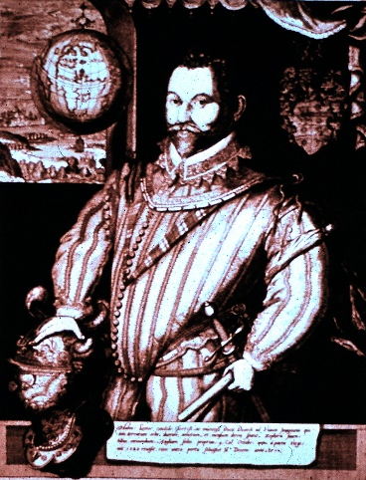
About 1540 -- Francis Drake born near Tavistock, Devonshire.
1550s -- Drake learns seafaring as a youth.
1556 --- Philip II becomes king of Spain.
1558 -- Henry VIII's daughter Elizabeth becomes queen of England.
About 1564 -- Drake is purser on a trading voyage to Spain.
1566-1567 -- Drake is an officer in the Lovell expedition to Africa and the Caribbean.
1567 -- Drake is an officer in the Hawkins expedition to Africa and the Caribbean and becomes captain of the Judith.
1568 -- Hawkins expedition is attacked in San Juan d'Ulua, Mexico; Drake escapes in the Judith, Hawkins in the Minion, both returning to Plymouth In 1569.
1569 -- Drake marries Mary Newman.
1570 -- Drake raids the West Indies with two ships.
1571 -- Drake raids Panama with one ship.
1572-1573 -- Drake raids Panama with two ships and takes a mule train with treasure.
1575 -- Drake serves under the Earl of Essex off the coast of Ireland.
1577 -- Drake sails for the Pacific by way of the Straits of Magellan.
1578-1579 -- Drake raids the Pacific coast of South and Central America, captures a treasure ship, then sails far north, sees southern Oregon, and refits in California before crossing the Pacific and Indian oceans.
1580 -- Drake returns to Plymouth, completing the circumnavigation.
1581 -- Queen Elizabeth knights Drake on the deck of his ship, the Golden Hind.
1581-1582 -- Drake is mayor of Plymouth.
1581-1586, 1593 -- Drake is a member of Parliament.
1583 -- Mary Drake dies.
1585 -- Drake marries Elizabeth Sydenham.
1585-1586 -- Drake takes Santiago, Cape Verde Islands; Santo Domingo, Hispaniola; Cartagena, Columbia, and St. Augustine, Florida, with twenty-five ships and two thousand men. He rescues the Roanoke colonists.
1587 -- Drake burns Spanish ships in Cadiz, Spain, and along the Portuguese coast with twenty-four ships and three thousand men, then takes a treasure ship off the Azores Islands.
1588 -- Drake is Vice-Admiral of England in the campaign of the Spanish Armada.
1589 -- Drake takes Corunna, Spain, and attacks Lisbon unsuccessfully with 180 ships and seventeen thousand men.
1593-1595 -- Drake is deputy lord lieutenant for Devon.
1595 -- Drake and John Hawkins sail for the West Indies with twenty-seven ships and twenty-five hundred men. Hawkins dies, and Drake's attacks are repulsed at San Juan, Puerto Rico, and in Panama.
1596 -- On January 28, Drake dies off Panama and is buried at sea.
1598 -- King Philip II of Spain dies.
1603 -- Queen Elizabeth dies.

Overview of the Voyage
Queen Elizabeth quietly invested in Drake’s voyage which set out late in 1577, ostensibly as a trading venture to the eastern Mediterranean. Off northwest Africa, Drake’s real course became evident: he was going to the Pacific Ocean via Brazil and the Straits of Magellan. Before entering the Straits, Drake quashed what he saw as an incipient mutiny by his second in command, Thomas Doughty, by ordering him to be tried and then beheaded. The Straits voyage was relatively easy, but a two-month storm in the misnamed Pacific Ocean cost him two of his three ships: one overwhelmed by the sea with all hands and a second separated by the storms, never to rejoin. Drake’s Golden Hind was blown so far south and east that he discovered Cape Horn and the open southern ocean -- a tempestuous waterway now called the Drake Passage which links the Atlantic and Pacific Oceans.
Finally, the storms abated, and Drake sailed north, raiding shoreside settlements and capturing ships along the coast of Chile, usually staying ahead of warnings of his coming. As always in his career, he treated captives well, learned much from them, and sent them on their way in ships which had been stripped of most of their sails. He sailed into Callao, the port of Lima, Peru, and cut the cables of the ships in the harbor so they would float out to sea with wind and tide to prevent pursuit. Captives’ stories of a treasure ship sailing toward Panama sent the Golden Hind in pursuit. Off Ecuador, Drake captured the Nuestra Señora de la Concepción with twenty-six tons of silver bars, thirteen or fourteen chests of pieces of eight, and eighty pounds of gold -- valued at half the annual revenues of his queen.
It was time to turn for home. The way south to the Straits of Magellan was barred by thousands of armed and angered Spaniards. The route west across the Pacific promised typhoons in the East Indies if he sailed at that time of year. Sailing north to find the western entrance to the Strait of Anian -- the route to the fabled Northwest Passage through northern North America -- seemed worth trying. So the Golden Hind sailed north to Guatulco on the southern coast of Mexico, then fifteen hundred miles out to sea, where she tacked northeast around the North-Pacific High to regain the coast and search for the hoped-for passage. It was not to be. Drake made landfall at the Oregon Dunes, finding that the land trended much farther to the west than he had hoped. There was no strait at that latitude. Relentless northwest winds forced him to turn south after a short anchorage in the insecure South Cove at Cape Arago. Three hundred miles of sailing along a dangerous rock-bound shoreline with no good harbors and steady onshore winds brought the Golden Hind to within sight of Bodega Bay, with the long Point Reyes Peninsula jutting eight miles into the ocean ahead of the ship. A turn to seaward cleared the beaches and the granite monolith of Point Reyes Head. Then, a sharp turn toward the east carried the ship past the three-mile-long headland and into the shelter of Drakes Bay, where a small cove inside the inner waterway of Drakes Estero provided the secure harbor Drake and his men sought. They needed to repair and resupply the Golden Hind for the trans-Pacific voyage that was the only remaining open route to the Atlantic and England.
Francis Drake landed at Drakes Bay, thirty miles north of San Francisco, on June 17, 1579, Drake’s men built a fortified camp, unloaded the Golden Hind and rolled her on one side and then the other to clean and repair her hull, filled the water barrels, and replenished her meat supply by taking and salting deer and seals. Drake’s chaplain held services from the Anglican Book of Common Prayer -- the first in this land. All the while, Drake and his crewmen met with the Coast Miwok Peoples in a friendly but uncomprehending series of interactions, including a ceremony led by a regional chieftain that concluded with Drake’s sitting down to be crowned with a feather headdress and adorned with shell-bead necklaces. Looking to the future, Drake marched inland for a day to see the nature of the land, and he made a formal claim to western North America in the name of his Queen Elizabeth -- the first English claim to the land that would, in time, become the United States of America. He named the land Nova Albion, or New White Land, after the great white cliffs which ring Drakes Bay and reminded the homesick Englishmen of their cliff-girt homeland whose ancient name was Albion.
Thirty-six days after arrival, Drake’s Golden Hind was ready to sail out of the little cove, into the bay, to the Farallon Islands twenty miles to the south, and into the deep Pacific. The voyage continued to more adventures: near shipwreck, a trade treaty in the Spice Islands, a long run across the Indian and Atlantic Oceans, a triumphant return to Plymouth, and a knighthood from Queen Elizabeth on the deck of his Golden Hind for Sir Francis Drake, the first English circumnavigator.

Voyage Timeline
15 November 1577 (Old Style) [25 November 1577 (New Style)] Drake leaves Plymouth, England with the Pelican, Elizabeth, Marigold, Swan and Benedict.
13 December 1577 (OS), after being forced back by weather and damaged ships, Drake leaves Plymouth with his repaired fleet. Sails to Africa, then Brazil and Argentina.
Swan and Benedict are abandoned before entering the Straits of Magellan.
20 August 1578 (OS) Entering the Straits of Magellan, the Pelican is renamed the Golden Hind.
7 September 1578 (OS), passes through the Straits of Magellan.
Sight lost of the Elizabeth, which returns to England.
8 September 1578 (OS), blown southeast (toward the Atlantic Ocean). Marigold sinks with all 29 hands. Drake discovers open water to south of Straits of Magellan, now known as the Drake Passage.
November 1578 – April 1579 (OS) Drake raids South and Central America.
1 March 1579 (OS) Drake captures Cacafuego off Ecuador including 26 tons of silver.
April – June 1579 (OS) Heads northwest seeking Strait of Anian (Northwest Passage).
5-10 June 1579 (OS) at precarious anchorage at Cape Arago, Oregon.
17 June – 24 July 1579 (OS) at Drakes Bay.
24-25 July 1579 (OS) at Farallon Islands.
July – September 1579 Crosses the Pacific Ocean.
9-10 January 1580 (OS) runs aground at Vesuvius Reef, Sualawesi.
15 June 1580 (OS) passes Cape of Good Hope.
22-26 July 1580 (OS) after setting record 9,700 miles sailing non-stop, repairs ship and resupplies at White Man’s Bay, Freetown, Sierra Leone.
26 or 28 September 1580 (OS) arrives Plymouth, England.
4 April 1581 (OS) Drake is knighted aboard the Golden Hind.
For a more-complete timeline, see Sir Francis Drake & The Golden Hind by Michael Turner.

The Golden Hind
The Golden Hind was a galleon of about 100 tons. This is a measure of the ship’s cargo capacity.
This is a wood ship. It is “square rigged” in that the primary sails hang from spars (poles) which run across the ship, so the sails are rectangular in shape. This gives the ship characteristic handling qualities.
The three vertical masts are the foremast (front), mainmast (center) and mizzenmast (rear). The mast angled out the front is the bowsprit.
There was no steering wheel on the ship. The rudder was controlled by a whip staff which gave the ship limited rudder throw.
Cooking was on a central galley in the middle of the ship.
Cannon were mounted along the main deck.
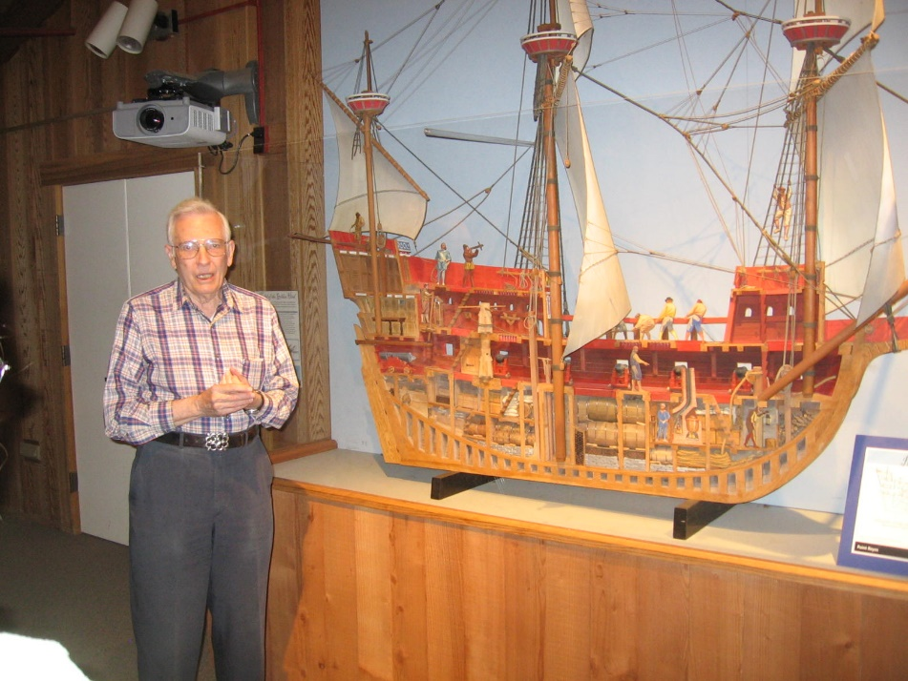
An excellent foreshortened half model approximately eight feet long is on display at the Bear Valley Visitors Center. The model is in the theater.

The Crew
164 sailors left with Drake’s ships in December 1577.
About 100 men manned the Golden Hind. The ship left with several noblemen aboard. After crossing the Atlantic Ocean, Drake made all the men work as seamen!
59 men returned on the Golden Hind to England.

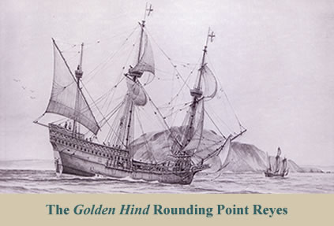

Drake at Drakes Bay
Coming from the north, Drake saw the Point Reyes peninsula ahead. Afraid of becoming embayed (caught by the wind in a bay), he swung out around the head.
Behind the head, he found “a fit and convenient harbor.”
Using a small boat, Drake explored the inner harbor.
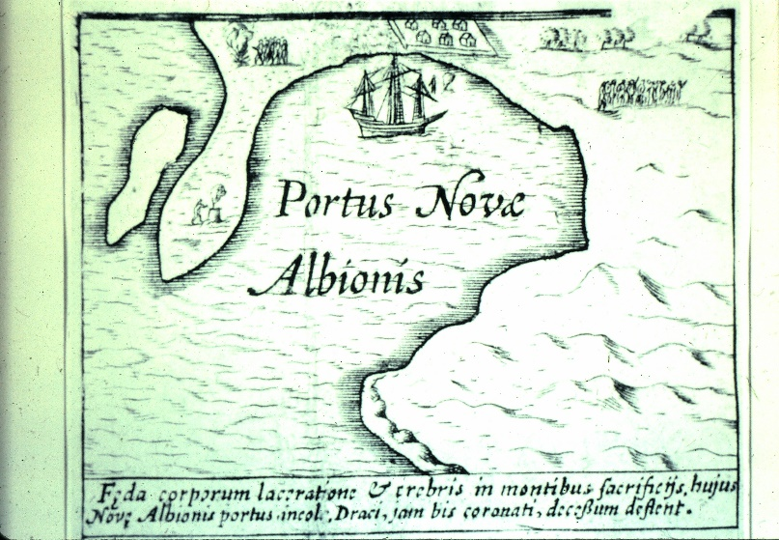
Just inside the estero, to the left, he found what is now called “Drake’s Cove.” The final identification of the Cove is the sketch from the Hondius Broadside map.
Drake spent 36 days at Drakes Bay.
Drake had several encounters with the Coast Miwok. These are described in length in The World Encompassed.
Leaving Drakes Bay, the Golden Hind spent a day at the Farallon Islands collecting supplies for the voyage across the Pacific Ocean.

Visiting the Landing Site
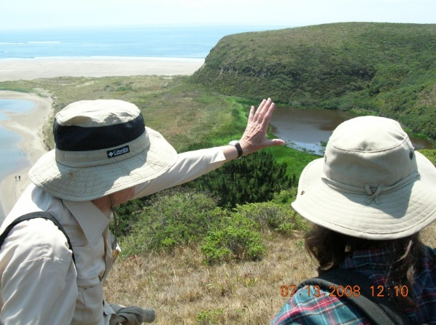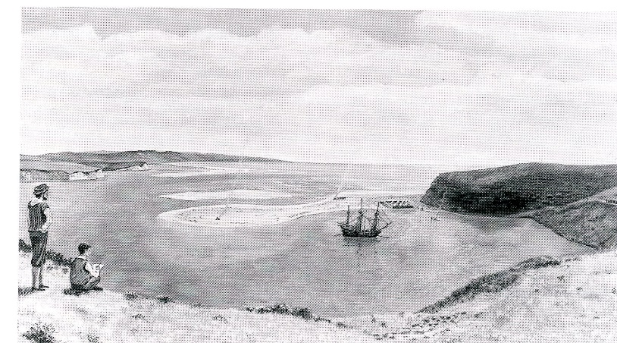
The landing site is reachable by a one-hour walk along the beach heading east from Drakes Beach. This is only possible during low tide and during months when the beach is extended (usually May to October).
It is also reachable by two cross-country routes. The assistance of knowledgeable persons is recommended.

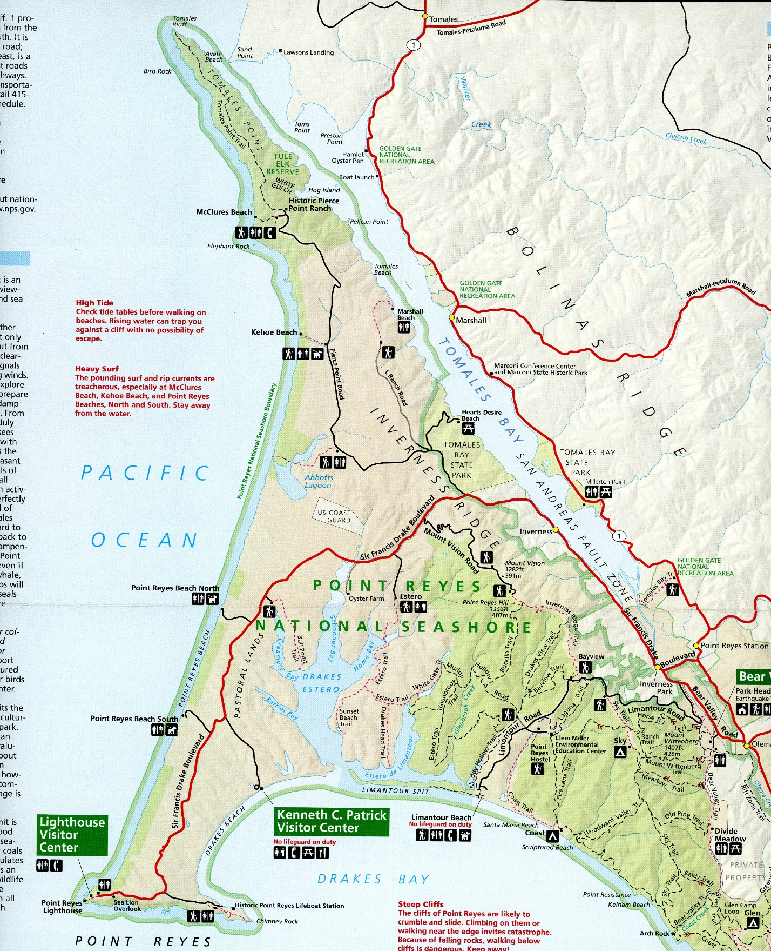
Location of NHL Plaque
To be dedicated 10/22/2016
Drake Landing Site at Drake’s Cove

Existing Monuments

At the landing site:
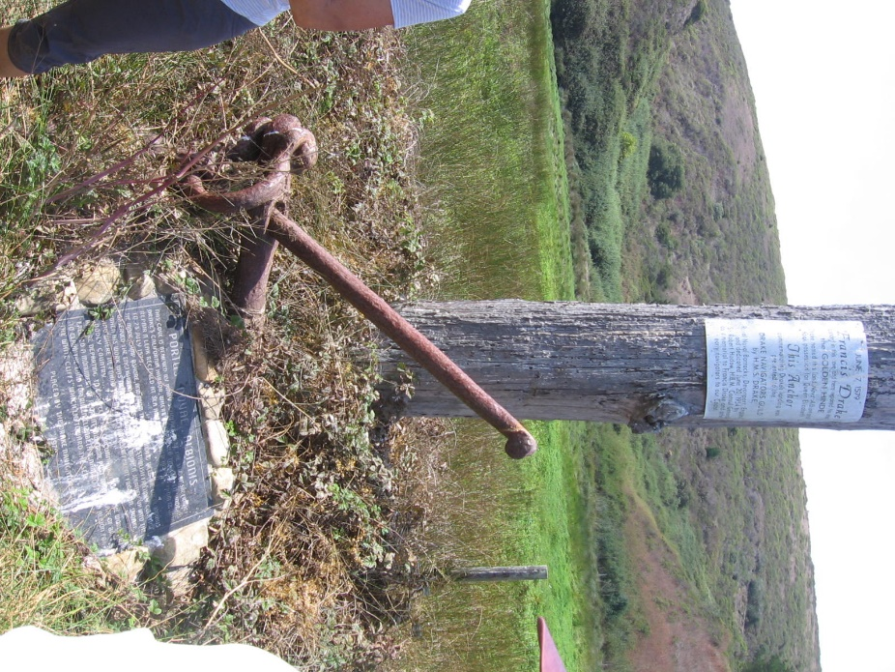
1954 monument from Great Britain with anchor

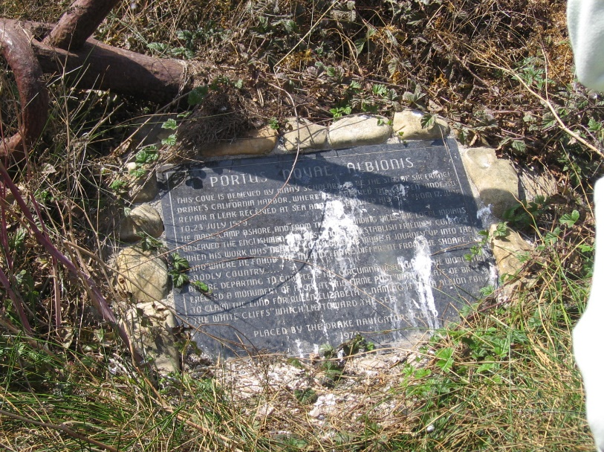
1979 Drake Navigators Guild plaque honoring 400th anniversary.

At the Lifesaving Station:
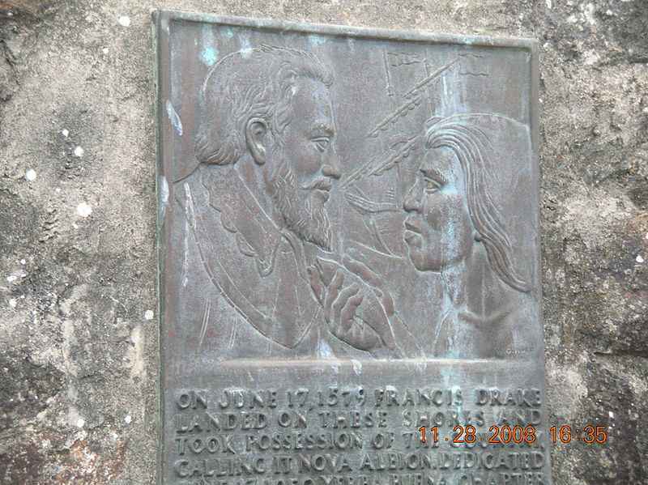
E Clampus Vitus plaque

At Drake’s Beach
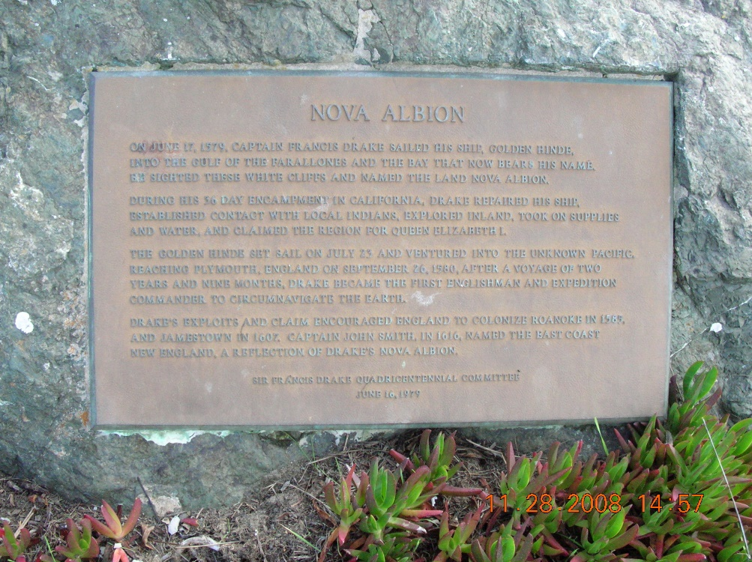
1979 Sir Francis Drake Commission plaque honoring 400th anniversary.

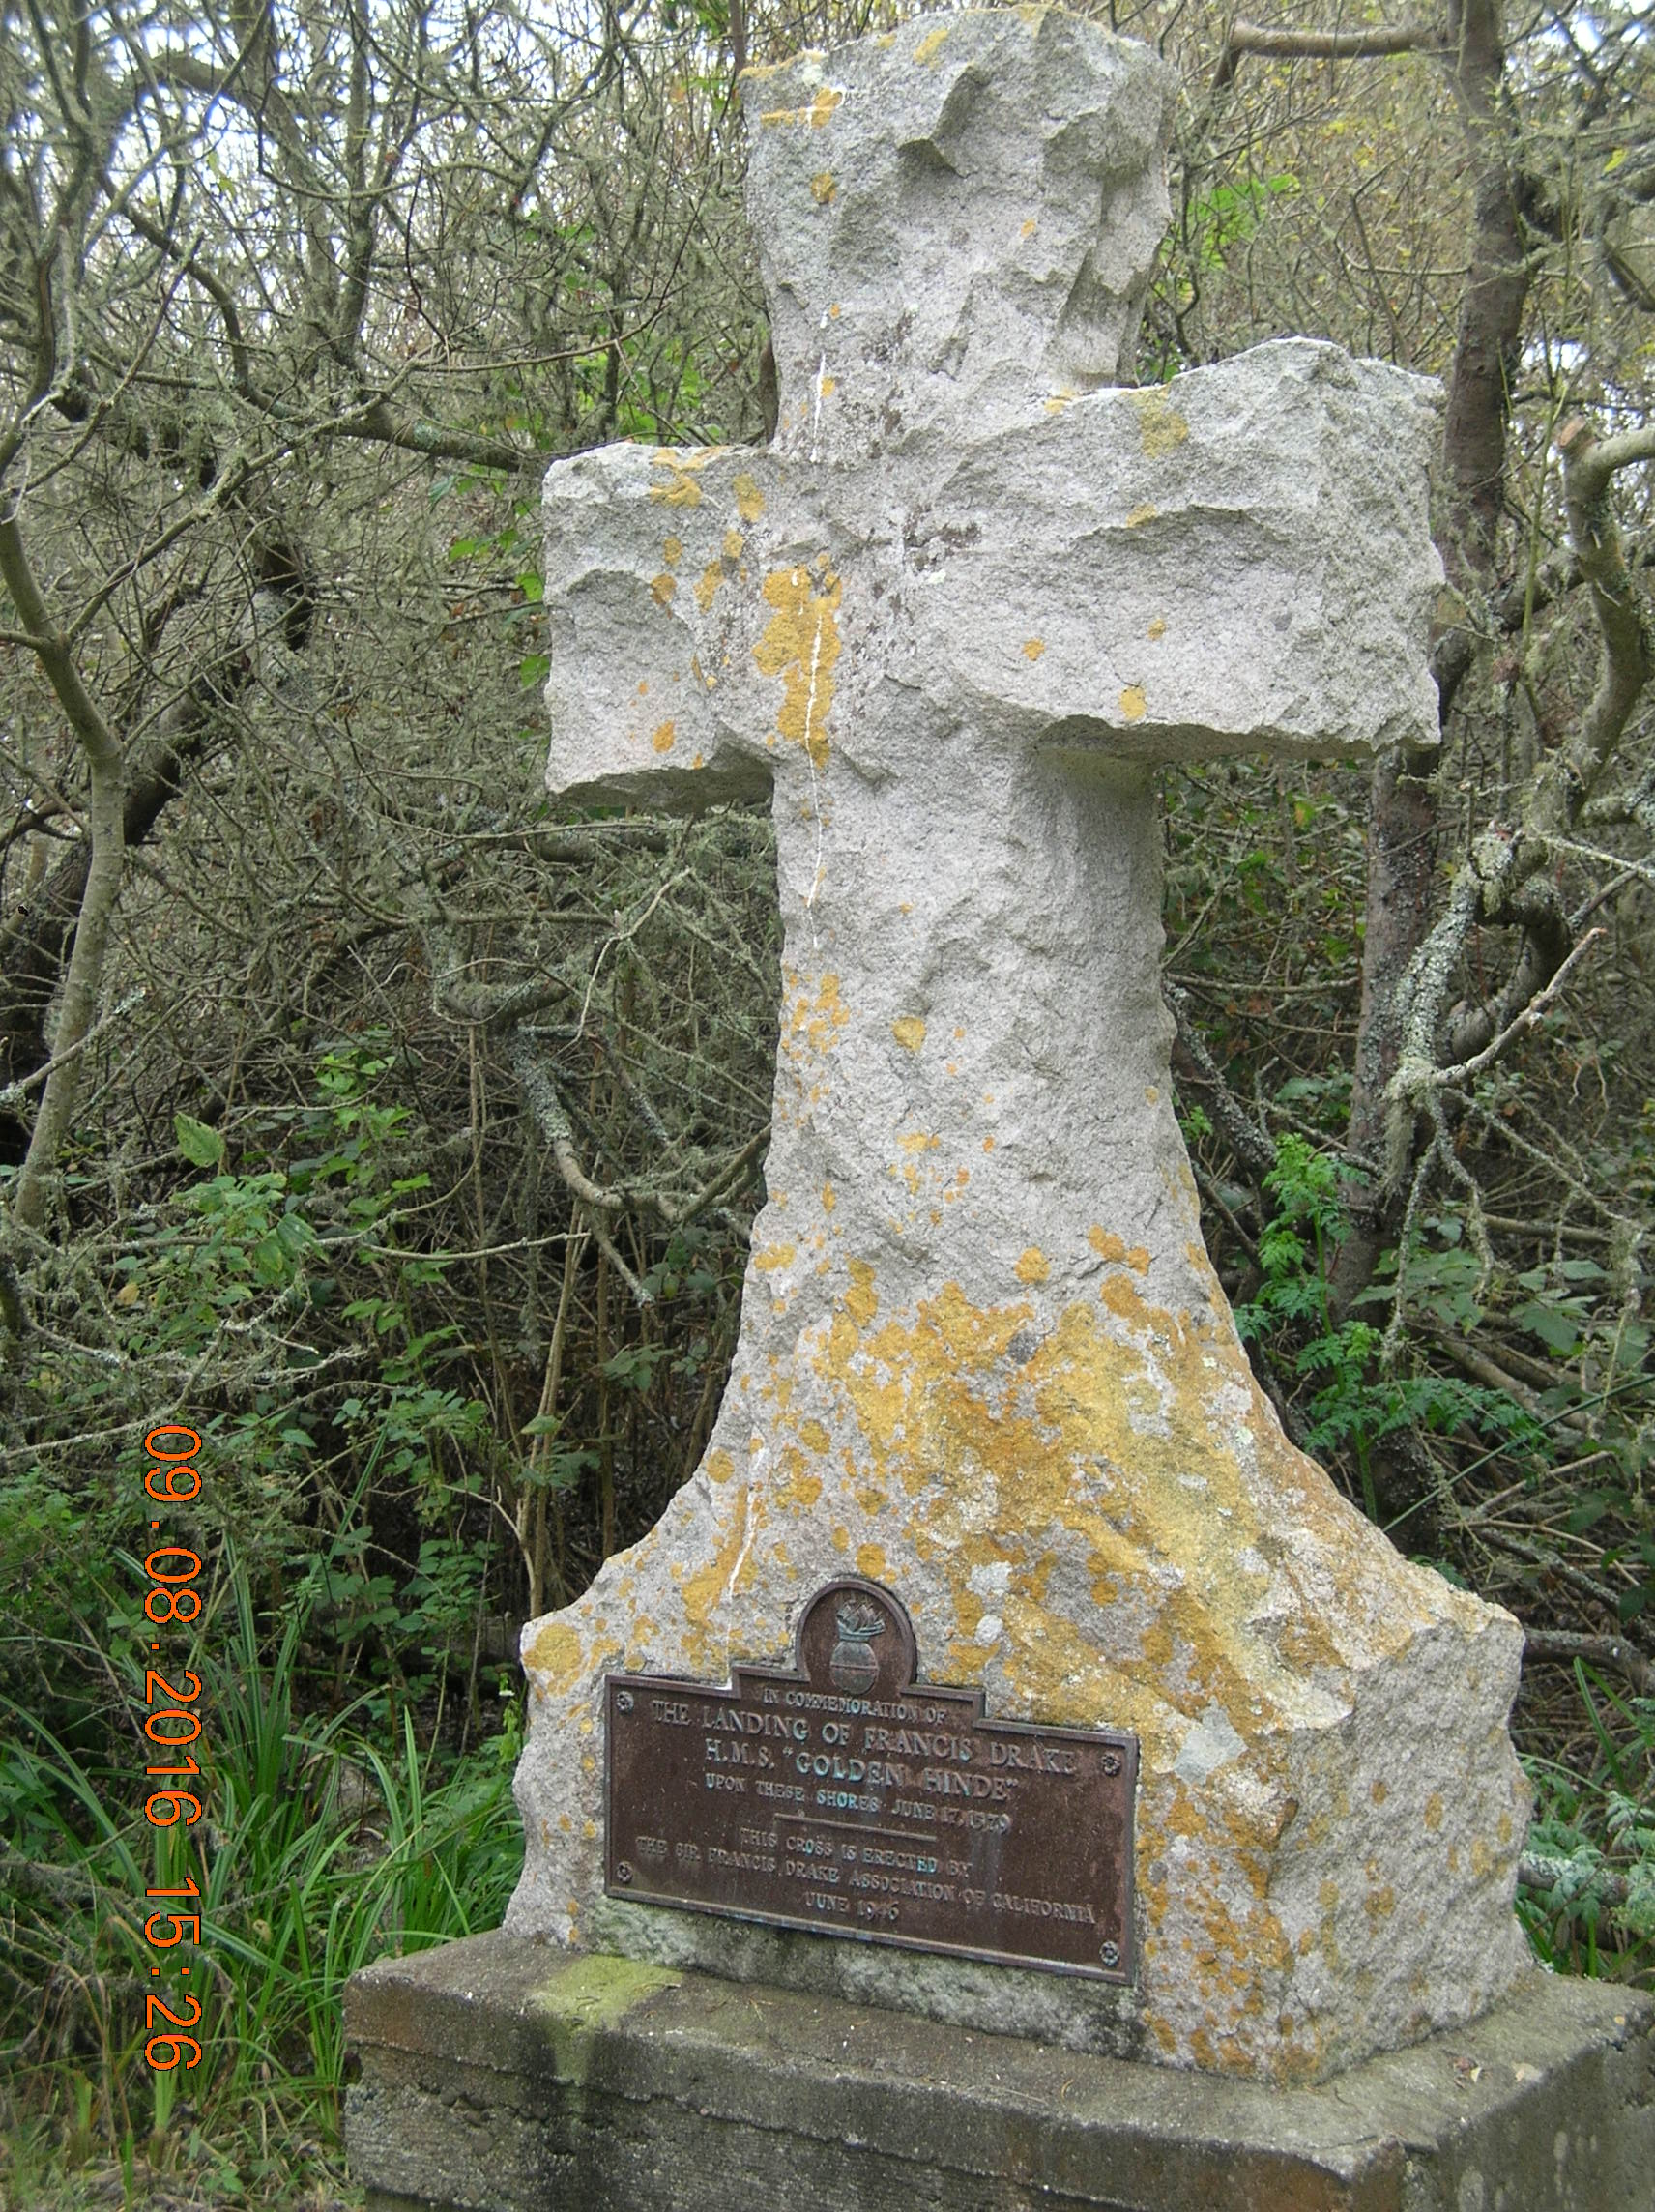
Also at Drake’s Beach is a large white cross. It was erected in honor of Drake by the Sir Francis Drake Association of San Francisco when the site was a Marin County park. The Association was closely associated with the Episcopal Church.

What is a National Historic Landmark?
A National Historic Landmark (NHL) is a building, site, structure, object, or district that is officially recognized by the United States government for its outstanding historical significance. Of over 85,000 places listed on the country's National Register of Historic Places, only 2,600 are recognized as National Historic Landmarks.
NHLs are sites to which the National Park Service directs people to visit to understand particularly important events and periods of American history.

The NHL Process
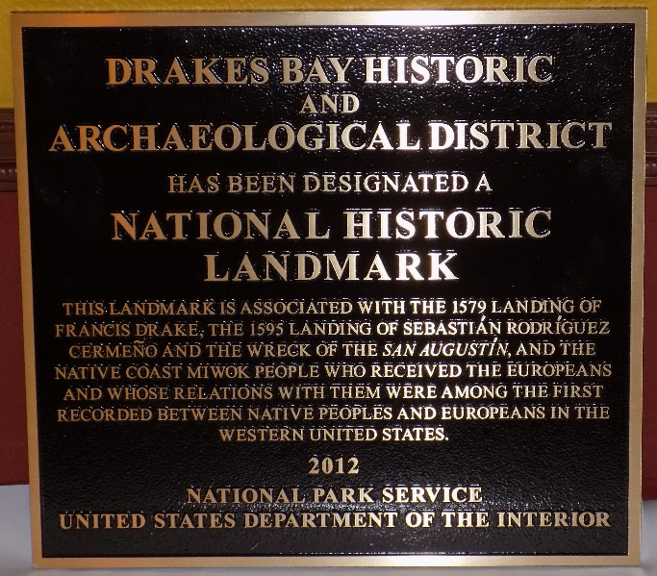
On October 17, 2012, United States Secretary of the Interior Ken Salazar recognized the Drakes Bay site as a new National Historic Landmark.
The Drake’s Cove site began its review by the National Park Service (NPS) in 1994, thus starting an 18-year restudy of the suggested Drake sites. The first formal Nomination to mark the Nova Albion site at Drake’s Cove as a National Historic Landmark was provided to NPS on January 1, 1996. As part of its review, NPS obtained independent, confidential comments from professional historians and other scholars. The NPS staff concluded that the Drake’s Cove site is the “most probable” and “most likely” Drake landing site and that it is the most appropriate site in the United States to commemorate Drake’s accomplishments.
The National Park System Advisory Board Landmarks Committee sought public comments on the Port of Nova Albion Historic and Archaeological District Nomination and received more than two dozen letters of support and none in opposition.
At the Committee’s meeting of November 9, 2011, in Washington, DC, representatives of the government of Spain, the National Oceanic and Atmospheric Administration, and Congresswoman Lynn Wolsey all spoke in favor of the Nomination: there was no opposition. National Park Service staff and the Drake Navigators Guild’s president, Edward Von der Porten, gave the presentation. The Nomination was strongly endorsed by Committee Member Dr. James M. Allan, Archaeologist, and the Committee as a whole, which approved the nomination unanimously.
The National Park System Advisory Board sought further public comments on the Nomination: no additional comments were received.
At the Board’s meeting on December 1, 2011, in Florida, the Nomination was further reviewed: the Board approved the nomination unanimously.
On October 16, 2012, Secretary of the Interior Ken Salazar signed the nomination and on October 17, 2012, The Drakes Bay Historic and Archaeological District was formally announced as a new National Historic Landmark.
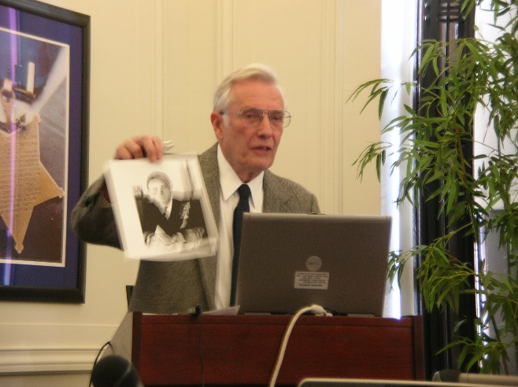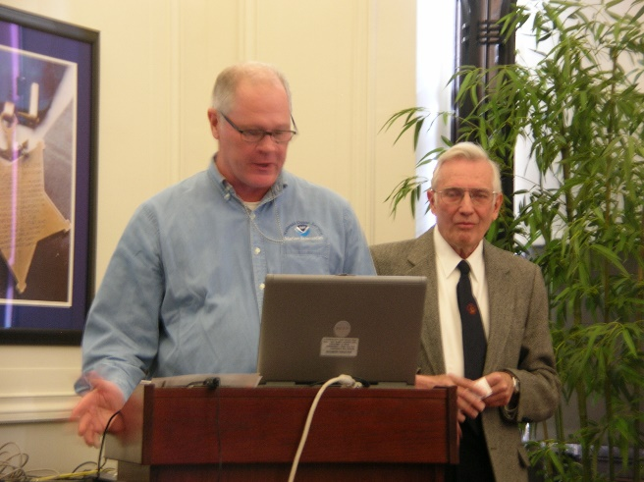
The November 2011 Washington, DC presentation
An application for the Register of Historic Places is a few pages long. The Drakes Bay National Historic and Archaeological District application is 123 pages long.

What is the District?
The Drakes Bay National Historic and Archaeological District recognizes the three peoples who met in the sixteenth Century at Drakes Bay: Francis Drake’s crewmen in 1579, Sebastian Rodrigues Cermeño’s crewmen in 1595 and the resident Coast Miwok people.
The District includes the English and Spanish landing sites and the Native American sites which contain sixteenth Century contact materials. To protect the archaeological sites, the actual boundaries of the District are classified. (This is common among archaeological NHL sites.)

Sebastian Rodrigues Cermeño’s Visit
Cermeño left the Philippines on his eastward Manila Galleon voyage on July 5, 1595 (Old Style). He had instructions to land at the first opportunity on the North American coast, assemble the launch carried aboard the San Agustin and explore southwards seeking an appropriate harbor for use by future Manila Galleons.
On October 29, 1579 (OS), Cermeño reached the Oregon coast at 42° north latitude. He coasted south, arriving at Drakes Bay on November 6th (OS).
The San Agustin anchored near the entrance to Drakes Estero, and most of the crew went ashore. In late November, a storm blew in from the south. The San Agustin dragged her anchors and was broken up in the surf.
Using wreckage from the San Agustin, the crew built up the small boat and sailed to Mexico.

The Coast Miwok
The Coast Miwok met both Drake’s and Cermeño’s crews at the shores of Drakes Bay.
The interactions between the Coast Miwok and Drake and his sailors is extensively described in The World Encompassed. Cermeño’s Declaration provides details of the Spanish meetings with the Coast Miwok.

How Did the Work on the NHL Get Done?
Most NHL work and document writing is done by paid consultants supported by private or government interests. The cost of each of these is often in the range of $100,000.
The Drakes Bay National Historic and Archaeological District Nomination was written by members of the not-for-profit Drake Navigators Guild with its members paying their own costs. Other scholars contributed to the Nomination in their fields of specialization.
The NPS staff in Washington, DC, in particular Mr. Kevin Foster and Dr. Erika Martin Siebert, was very helpful in sheparding the NHL application through its process.

The Plaque Ceremony
While most plaques are put up with an appropriate ceremony and associated events within months of their approvals, this ceremony has been a long time in coming.
Staff constraints at the Point Reyes National Seashore led to delays until its accomplishment on 22 October 2016.

The Drake Navigators Guild
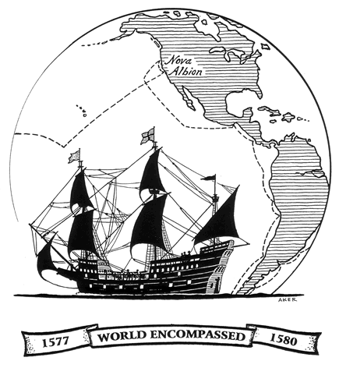
The Drake Navigators Guild is the historical research group which has used multi-disciplinary methods to research Francis Drake’s visit to the west coast of North America in 1579 and related maritime explorations. Founded in 1949, the Guild’s research supports the long-standing conclusion that Drake’s “Nova Albion” is at Drakes Bay, California. The Guild's efforts build on the research of Professor George Davidson and others who have studied Drake's voyage. The Guild’s research has identified the specific careening site at Drake’s Cove within the Bay. The DNG wrote the National Historic Landmark application and presented it to National Park Service committees. The group continues its educational and research efforts to bring the Drake story to the public.
Key participants over the years include
- Captain Raymond Aker
- Robert W. Allen
- F. Richard Brace
- Matthew P. Dillingham
- Captain Daniel Dillon, USN
- Fleet Admiral Chester W. Nimitz, USN
- Captain Adolph S. Oko, Jr.
See the Drake Navigators Guild website or Wikipedia for more information.

Establishing the Location
The location of Drake’s landing site has been established using more than twenty pieces of evidence. There are more than 50 details pointing to the landing site. All fit Drakes Bay.
Robert W. Allen argued that only three points of evidence needed to be used: the latitude, the white cliffs and the Farallon Islands are enough to establish the location of the bay. The other evidence supports these points, identifies the exact location of the encampment and inner harbor, and adds detail to the story.
The exact location of Drake’s Cove was determined after photographs taken by Matthew Dillingham were developed in 1952. These photographs match the drawing on the Hondius Broadside map.
While more than two dozen claims have been made that “Drake landed in my backyard” from Canada to Santa Barbara, none hold up to careful examination.
After years of study, the National Park Service and the Secretary of the Interior have agreed that the landing site is at Drake’s Cove.
The Appendices to the NHL nomination examine each of the claims in detail.
See Wikipedia – Drake in California for information on the 50 detailed points of evidence placing Drake at Drake’s Cove. For more details, see Raymond Aker’s 1970 book Report of Findings Relating to the Identification of Francis Drake’s Encampment at Point Reyes National Seashore.
See Wikipedia – Fringe Theories on the location of New Albion for information on the two dozen plus sites.

Resources
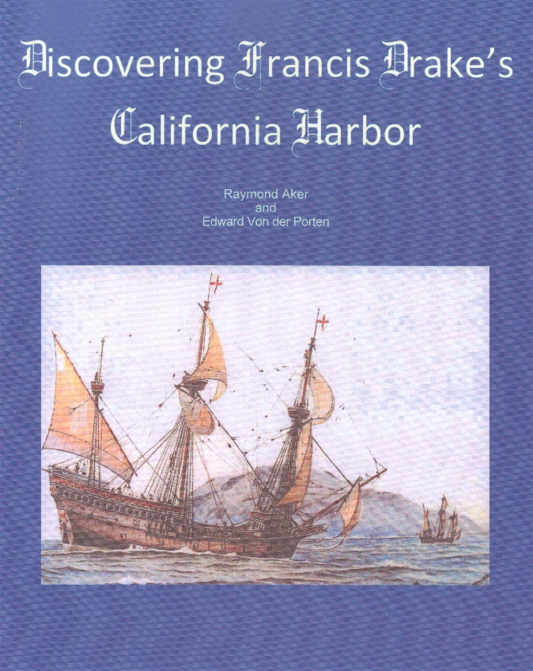
A 74-page publication summarizing Drake’s landing, Discovering Francis Drake’s California Harbor by Raymond Aker and Edward Von der Porten (2010) is available from the Drake Navigators Guild for $13 including postage and tax. This is the best summary of Drake’s Point Reyes visit. (This is available for sale through the Drake Navigators Guild or at the Point Reyes National Seashore.)
Photographs may be found at www.drakenavigatorsguild.org or through the Point Reyes National Seashore. The late Raymond Aker produced a number of excellent drawings of the Golden Hind and Drake’s encampment. Gordon Miller has produced a few outstanding watercolors of Drake’s visit.
Interviews may be arranged with Edward Von der Porten, President, Drake Navigators Guild. A sample interview is available at http://www.nbcbayarea.com/news/local/144501805.html.
NBC’s Brent Cannon (left) interviews Edward Von der Porten - 2012
See below for contact information.
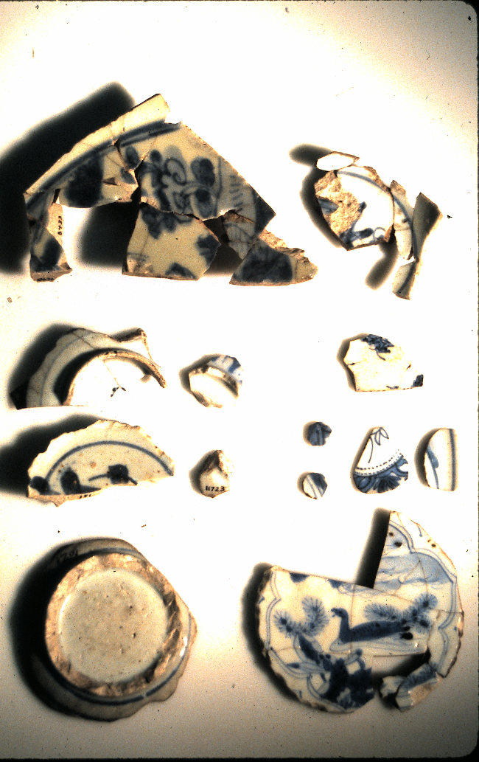
Original porcelains from both the Drake and Cermeño visits may be seen by contacting Mr. Von der Porten or the National Seashore.
Since the object of the Manila Galleon trade was to get high-value cargoes to the European market, such porcelains have been held in private collections for centuries. For photographs, please contact Mr. Von der Porten. Note that an exhibit of these porcelains will be at the Sonoma County Museum in the fall of 2017.
Site visits to the Drake landing site may be arranged.
Copies of publications examining the Drake landing are available at the Drake Navigators Guild’s website.
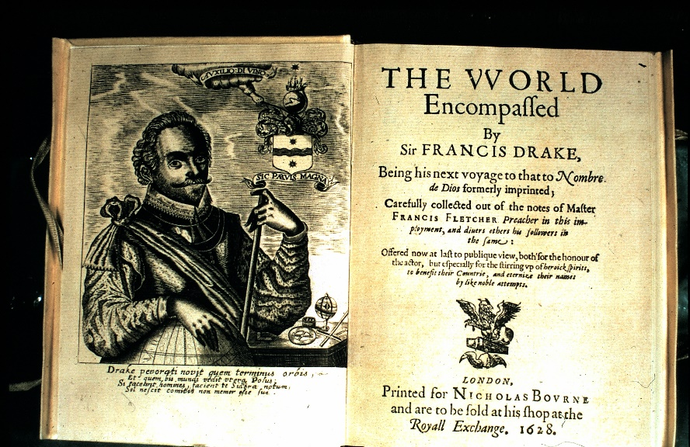
The World Encompassed by Sir Francis Drake (Sir Francis Drake’s nephew) offers the best contemporary record. The portion about Marin County is the most extensive in the book: this area was unknown to Europeans before Drake’s visit. (Copies can be purchased online and copies have been scanned and made available online.)
The best general biography of Drake is Sir Francis Drake by John Sugden. Note that the section on the California visit in earlier editions is not complete, so readers should seek a current edition. (Copies are readily available through online and bricks-and-mortar bookstores.)
Analyses of the porcelains found at Drakes Bay, and the botanical and biological features are also available through the DNG website.
The Golden Hind model at the Point Reyes National Seashore Visitor Center makes an excellent background for reporting the story. The model can be explained by DNG representatives.
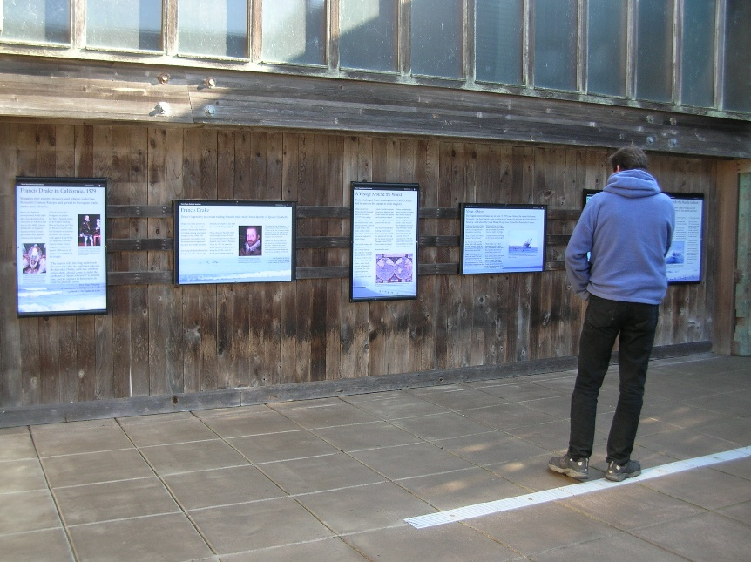
A series of interpretive panels is mounted at the Ken Patrick Visitors Center at Drakes Beach. These may be used for a photo background.
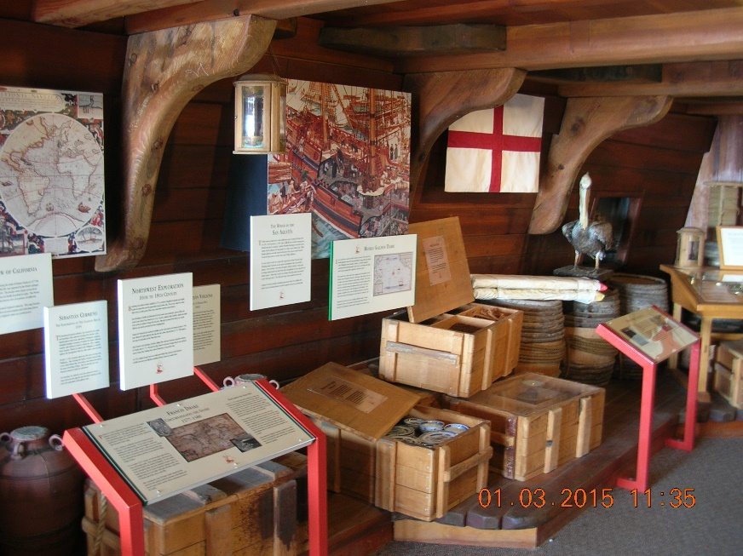
A few exhibits about the Drake landing are inside the Ken Patrick Visitor Center at Drakes Beach. Hours are limited: check with NPS before heading out there.

The October 22, 2016, Events
The celebrations on October 22, 2016, are being run the National Park Service (NPS). The Point Reyes National Seashore Association (PRNSA) and the DNG are supporting the events.
Details may be obtained from NPS. The general plan is that the ceremony will be held at the Limantour Spit parking lot at 10 AM followed by activities in the areas around the Point Reyes National Seashore Headquarters following the ceremony.

Technical Notes
“Drakes Bay” has no apostrophe.
“Drakes Estero” has no apostrophe.
“Drake’s Cove” does have an apostrophe.
“Drake’s Beach” does have an apostrophe. Drake did not land here, but it is the closest road access point to the landing site. The 400th Anniversary celebrations were held here in 1979. This is also the site of Lady Bird Johnson’s dedication of the Seashore.
The Old Style (OS) dates were changed in Great Britain in 1752 to New (NS) dates. To convert dates from OS to current (NS) dates, add 10 days.

Contact
Drake Navigators Guild – Edward Von der Porten – (415) 664-7701 – edandsaryl@aol.com
For the latest version of this advance guide, contact mikevdpca@aim.com.

